Inventory flow from Delivery Co (Swiggy Zomato)

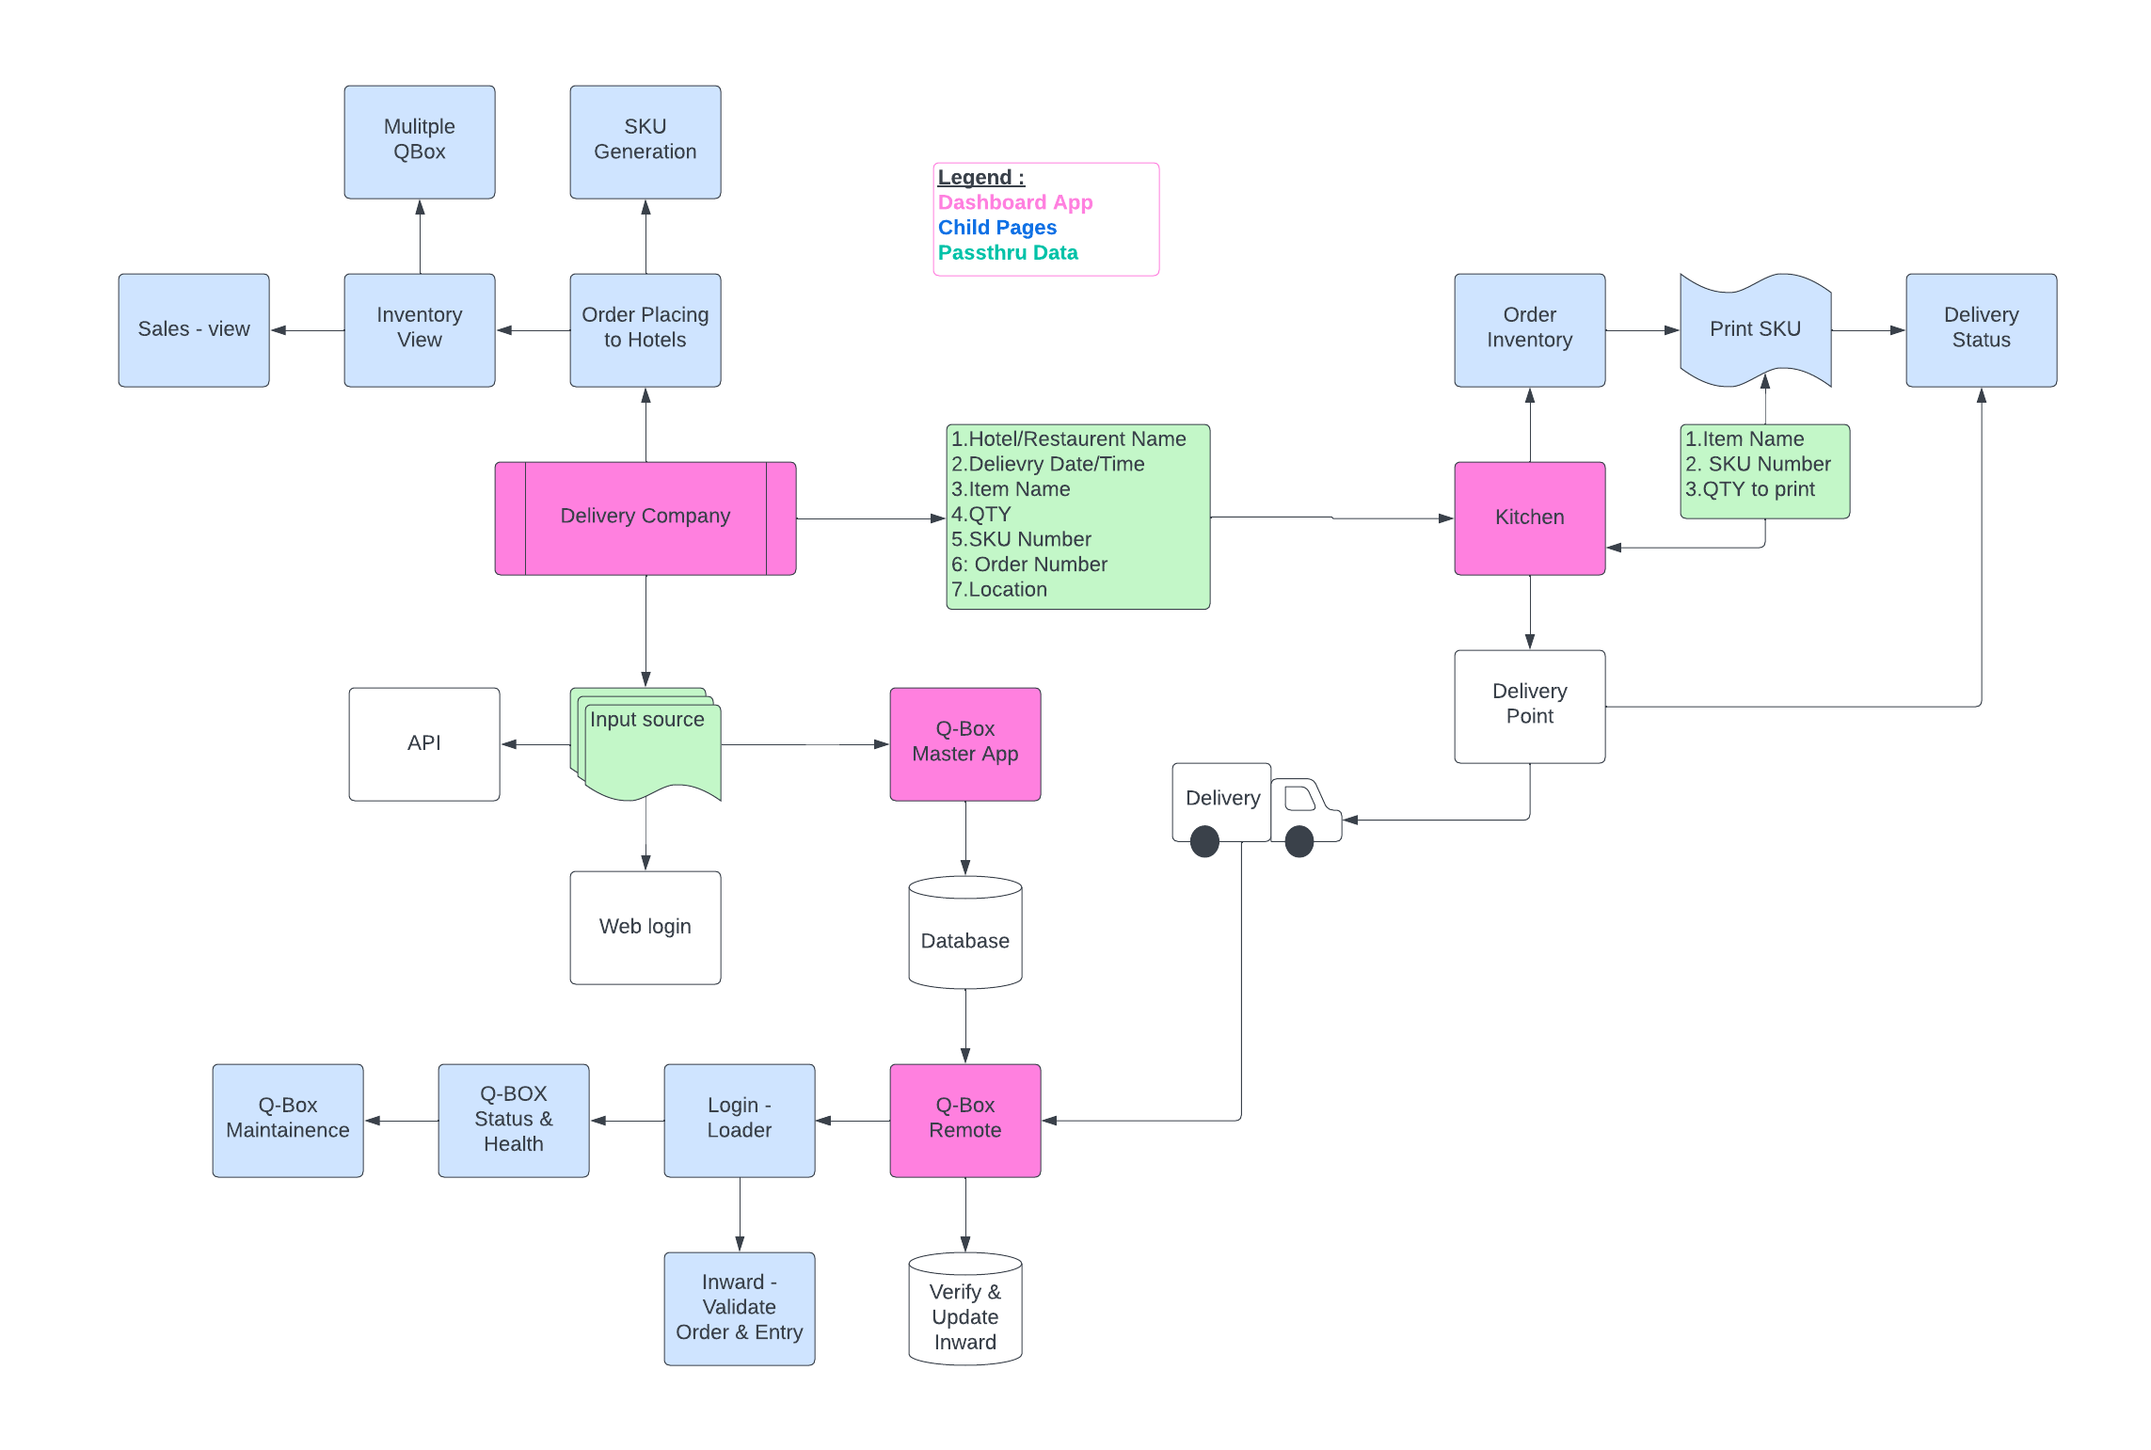

Inventory Update at Q-Box

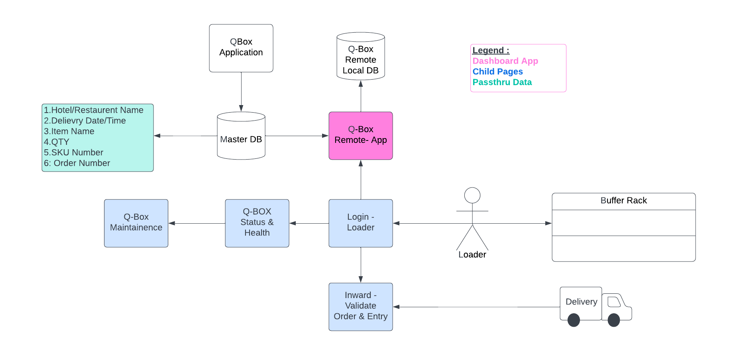

Operations @ Qbox Remote

